THE STOLEN IDENTITY
## Scenario
Sometime in the last 24 hours, someone got access into the Mad Hat Labs tenant. They didn't kick down any doors using any zero-day exploits on anything. They walked right in through the identity plane and were quiet about it. No alarms were tripped. The Mad Hat Labs security team were NOT notified of any MALFEASANCE. The logs just show a series of perfectly normal sign-ins.

## Environment
live multi-user Azure training tenant, Reader access.

## Investigation

Entry:
So far, we have determined that an employee was a victim of an OAuth phishing attack. The attacker targeted the employee with a portal that looked almost identical to the portal that the employee normally login into. The employee information at that point was stolen and the attacker used that information to breach the company data.
- To start my investigation, I signed into azure portal and navigated app registrations to see if any notes were input inside the note’s property. The reason for checking the note property is because every app registration carries a internal notes property under branding and property inside Azure portal.
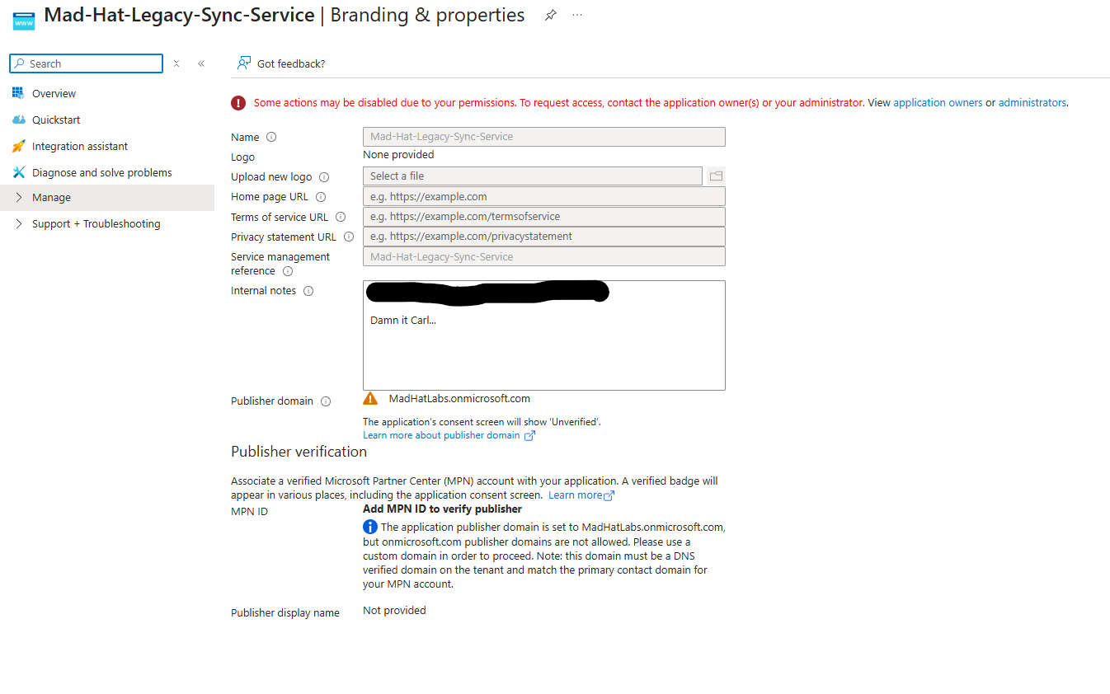
Escalate:
Since Carl company credentials were compromised, I need to look at what privileges Carl currently have. I know Carl is an Accountant for the company, so he didn’t have privilege on their account, but the legacy app he did. The bad actor can escalate their privileges immediately by using Carl’s owner rights to drop a new credential into the app. The bad actor can create a new password for Carl and elevate their access from standard to highly privileged granting access to the app directory
- I access Certificate and Secrets on the legacy app and notice that the secret that the secret created has expired 12/31/209. It shows that the bad actor is preparing to stay for a long time.
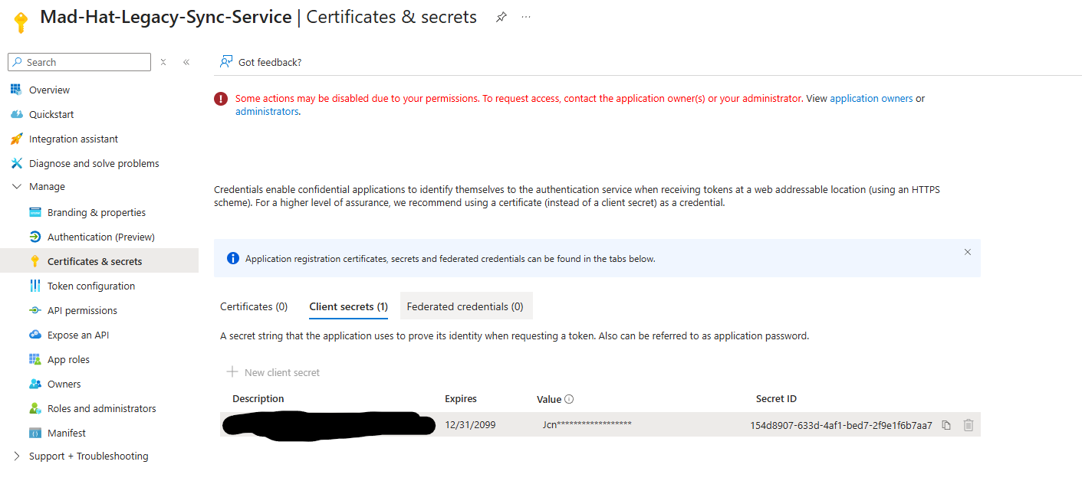
Pivot:
The bad actor knows that the stolen secret from Carl can be easily rotated to a new secret which would stop the attacker in his/her tracks. For the bad actor to have a more perinate resident inside Mad-Hat-Legacy-Sync-Service app, the bad actor created a new app (Mad-Hat-Labs-App). Whenever creating an App Registration in Entra ID, Microsoft also creates a Service Principle for that application. The bad actor took the service principle belonging to Mad-Hat-Labs-App and made it the Owner of the Mad-Hat-Legacy-Sync-Service app. Looking at the API permissions for the Mad-Hat-Legacy-Sync-Service app, the permissions were granted with admin consent. This also give me an idea of the potential blast radius of the attack. 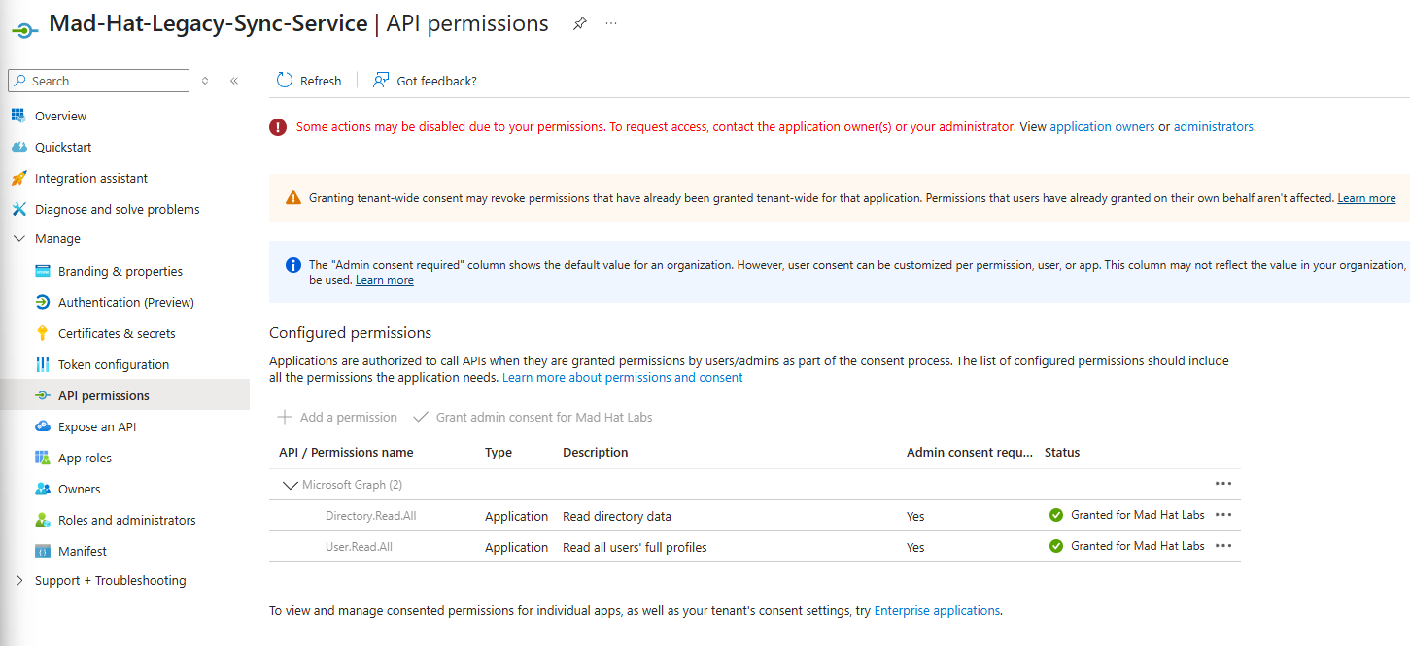
- I investigated the suspicious app for any notes inside the notes field in branding and properties blade.
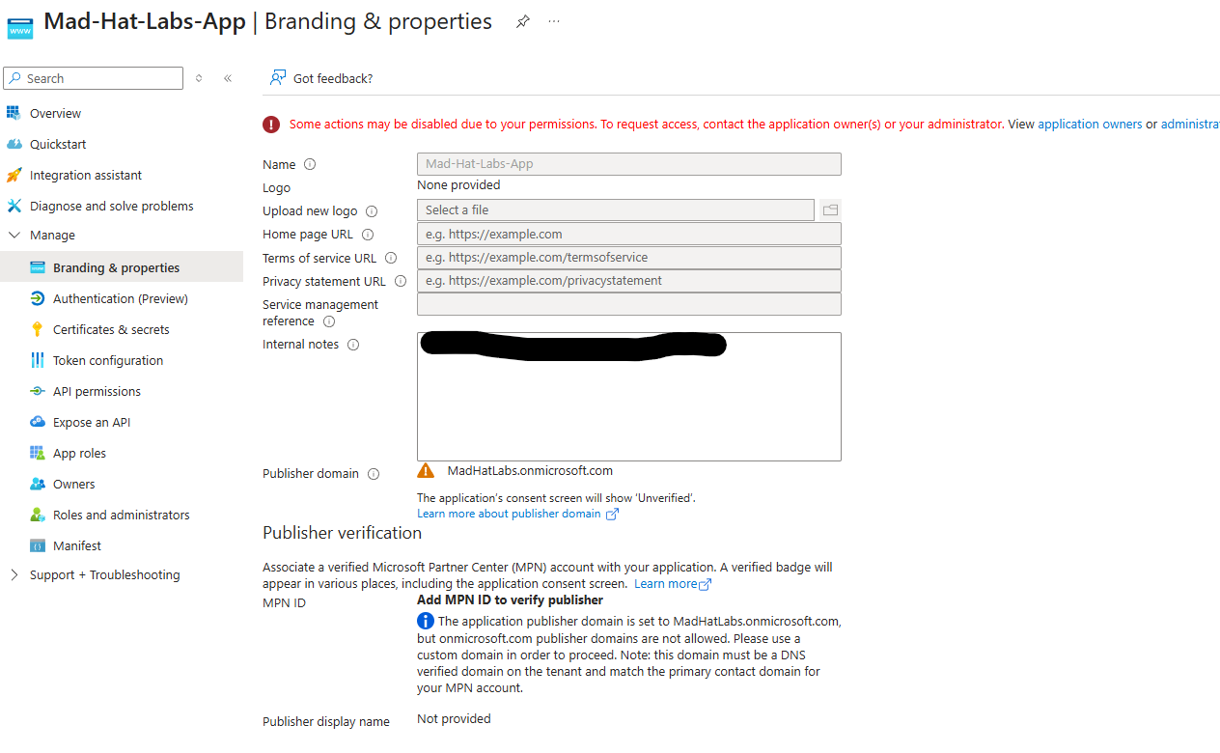
Persistence:
The bad actor is probably aware that standard practice for accounts or services that was implicated in a breach of secrets will be rotated. This bad actor had a back up plan to maintain access if the secret rotation occurred. The bad actor used Expose an API on the Mad-Hat-Legacy-Sync-Service app. Expose an API tells Entra ID that other apps are allowed to request permission to call my app.
- I went inside the legacy app and Open Expose an API blade and see the permission that the bad actor created.
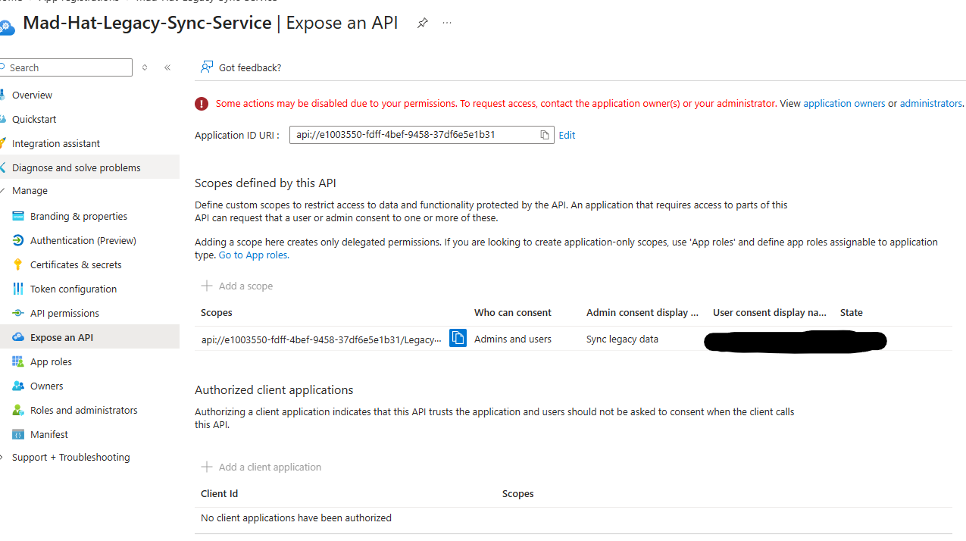
The Loot:
Now that the bad actor is in and a back plan was created to keep access if secrets rotate. The bad actor focused on token that proves Microsoft already trusts him/her. A redirect URI is the address Microsoft sends you back to after logging in. The bad actor now controls the redirect address.

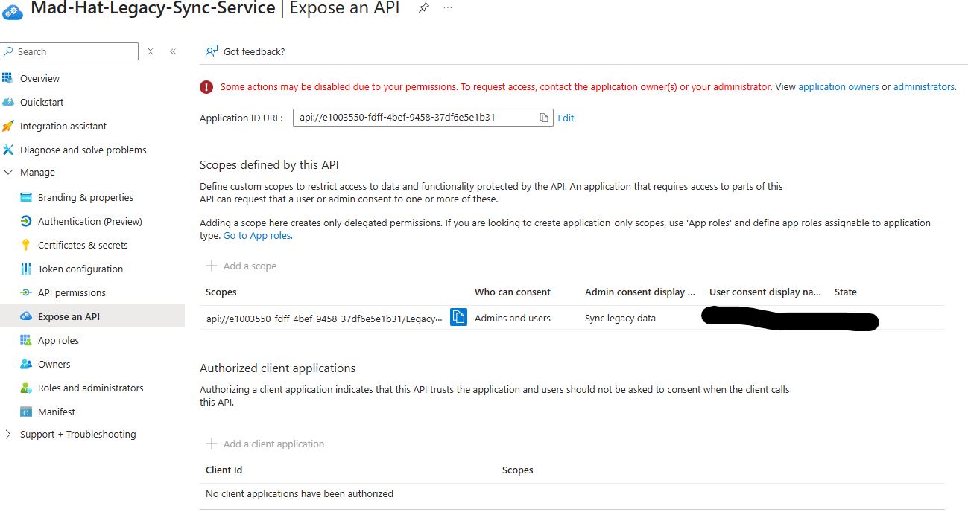

## What broke / what surprised me
I didn’t realize how powerful OAuth can be until working through this lab. What surprised me was how the bad actor chain of actions could start with OAuth application permissions rather than simply stealing a password.

## Findings and recommendations
Findings:
One finding was that a legacy application had highly privileged API permissions, including Directory.Read.All and User.Read.All. These permissions created a significant risk because the application had broad access to directory information and user information. Another finding was the use of a long-lived client secret. The secret had an expiration date set far into the future, which could allow an attacker to maintain access for an extended period of if the credential was not discovered and removed. The investigation also identified an additional application owner. This created a persistence risk because the owner may be able to manage the application and potentially create new credentials even after an existing malicious secret was removed. A suspicious redirect URI was also identified on the rogue application. The redirect URI pointed to attacker-controlled infrastructure, meaning authorization codes generated during the OAuth flow could be delivered to the attacker-controlled application.
Recommendations:
- Organizations should regularly review app registrations and enterprise applications for unnecessary or excessive API permissions. Highly privileged permissions such as Directory.Read.All and User.Read.All should only be granted when there is a documented business requirement.
- Client secrets and certificates should be reviewed frequently. Long-lived credentials should be avoided, and the organization should use shorter expiration periods and credential rotation whenever possible
- Application ownership should also be audited. The organization should verify that every owner is still required and that former employees, unused service principles, and unknown applications are removed from ownership roles.

## What I learned
- How attackers can abuse OAuth. An attacker doesn’t always need to steal a user password or log in directly as that user. If a user consents to a malicious application, the attacker may be able to obtain delegated access through OAuth with resources on the user’s behalf.
- Highly privileged API permissions can create serious risk, especially when they are assigned to older or poorly monitored applications. Permissions such as Directory.Read.All and User.Read.All can give an application broad access across the tenant.
- Long-lived client secrets and additional application owners can allow an attacker to maintain control even after the attacker created secret is removed. This showed that sometimes simply changing a password or removing a secret may not fully remove an attacker from the environment.
- I would investigate the full relationship between users, applications, service principles, permissions, and resources.

